Austin Parks Board Meeting
Agenda & Minutes May 2, 2022 6:00 pm
Call to Order-6:15 pm
Members present- White, Buchanan, Hollan
Guests – None
Review April minutes and approve. White moved to approve, Hollan Seconded vote 3-0
Old Business:
- DNR- Application submitted to Federal DNR December 1st. . Waiting on results. Next update in May, Still VERY optimistic. FYI

- Fencing at Spicertown Park working with trustee all money encumbered. Waiting on weather Border clearing and removal of Blue Double wide

- Double wide issue still open. It has sold, will be removed in near future. Can the city give an upate?

- Formally asked for a street light at 6th and Cross. Council City Council agreed, but want to wait until they install Solar units.

- Need to meet with city and consultant, Baker and Tilley, on option to impose a park tax levy on new home construction- Buchanan and White will follow up with Mayor Hawkins. Need to reach out to Chris Fugate- President Buchanan has update. Probably not feasable

- When the sidewalk work starts we want align with putting electric along HWY 31- Shared this with City Council Work will start soon.

- When we get the DNR grant, we need to work with city to get a construction access to the proposed property acquisition through either North or Rural St. No movement. Need to discuss with city attorney.

- Netting on Large field- Discussed in detail along with other Baseball field needs. White move to approve $2,000.00 for items recommended by President Buchanan, with condition we approach Baseball board about sharing some costs Buchanan Update City workers have promised several times, no progress

- Manaugh Pond treatment.. Order placed

- Decide on How to handle Nuisance Geese- Options discussed, Ishmael White will contact DNR certified lists of Waterfowl Control Operators to get costs and options. Ishmael White talked to Geese Away- they will trap and relocate of $700.00 fee plus $15.00 dollar per goose- $955.00 total for 17 geese White moved to proceed, Hollan Seconded, Vote 3-0. Money will come out of Christie Fund

- Dedication of Campbell Park, Who, When, How April 23rd, 11:00 am. Went very well good turnout. Got 5,000+ views on facebook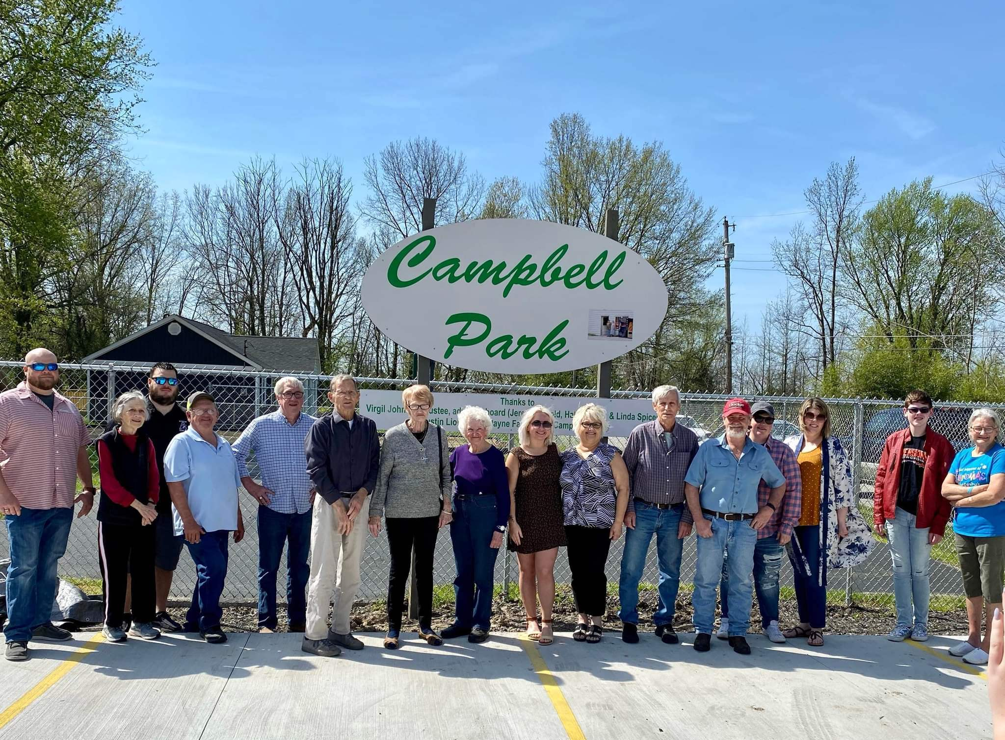

- Centerstone asked to use shelter on May 14th. Approved No charge.

- We need a plan for moving the playground equipment that was donated by the school. Bid review. Great price! $3,560.00 White to approach Trustee to Fund, Hollan moved to do it, White seconded, Vote 3-0

- One set of aluminum bleachers on the middle field have significant damage on bottom row. Need replace with ones at sewer plant. Done

- Bathroom opening and cleaning- Glen Hollan will do it.Hale made motion, Baker seconded vote 6-0. Buchanan to reach out to baseball association to help with this cost. Baseball Association refused- FYI
New Business:
- Need to do some landscaping at Campbell Park- Discussed approach and amount 4 single axle loads. To do later in the year.

- Side by side battery status HELP HELP HELP

- Moving stuff up to new maintenance building- We need to move all park stuff, leave items need by Street Dept and prisoners

- Tree cutting at Broadway – We still have approximately 20 trees that could come down

- Landscaping at Spicertown Park General Dicussion

- Clean up around old concession stand- Need to get city to remove

- Tree down at Archery Range- Tree has been cut up. White to approach Floyd Cain on new top rail
Walk-ins:
- Bottom railing on backstop at North Field. White to approach Floyd Cain on it.

- Lady wanting to use shelter hose on May 21st for fundraiser for funeral expenses- White agreed to have the person call him to discuss- Met her at building on Saturday and agreed

- Discussed have City Clerk Tresurer provide us Claims for park on First Manday, so we can review and sign off, for approval at following Tuesday City Council Meeting- Buchanan to make request of City Clerk Treasureer.
Adjourn: 7:05 PM

